Alarm: ID 13: Right FTC Alarm
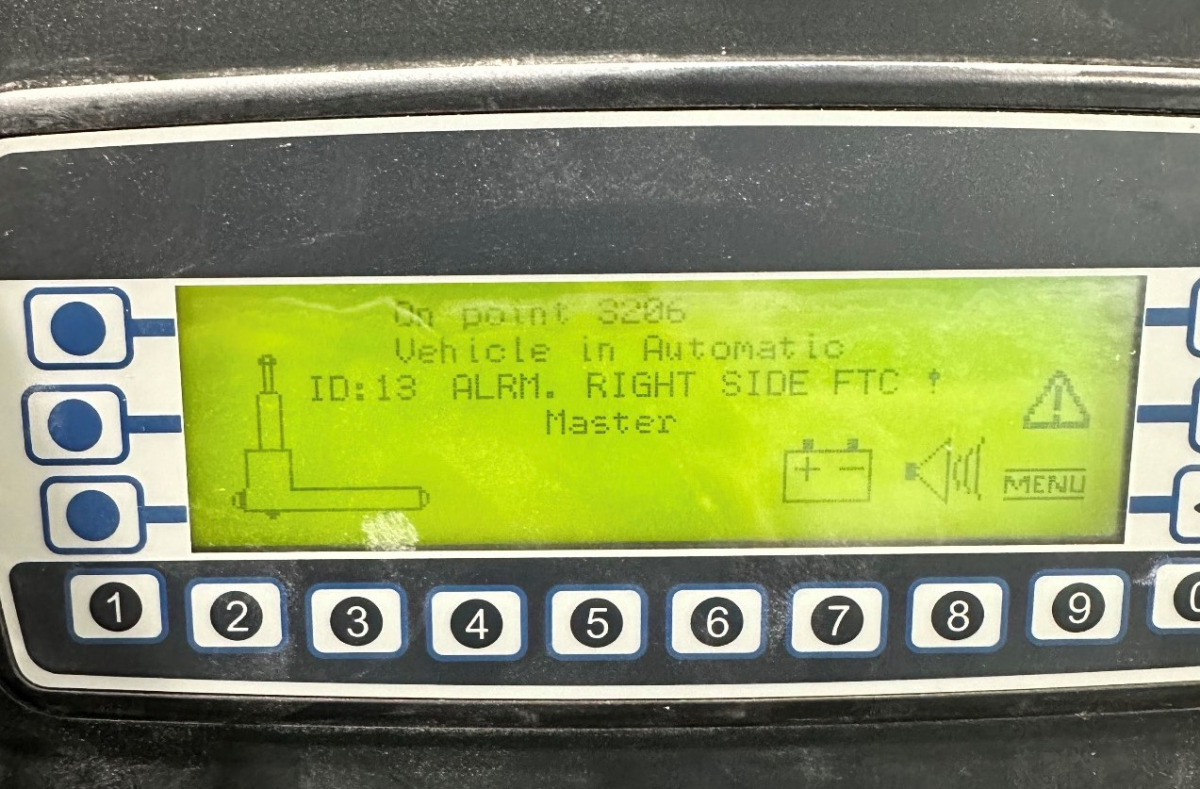
How To Fix:
Each AGV has a right and left arm. This alarm is triggered when there’s an obstruction in the right arm.
To resolve:
- Clear the obstruction from the right arm of the AGV.
- Perform the automatic sequence:
  - Automatic Mode
  - Press the Blue button
  - Press the Green button

